Contents

**Maghi: A Historical and Cultural Overview** 1

**Introduction** 1

**Origins and Historical Background** 1

**Maghi in Vedic and Hindu Tradition** 1

**Sikh Significance: The Forty Martyrs** 1

**Cultural Observance and Festivities** 1

**Maghi Mela at Muktsar Sahib** The most prominent celebration takes place in Sri Muktsar Sahib, Punjab, where thousands gather annually for the Maghi Mela. Pilgrims take a holy dip in the sarovar (sacred tank), attend religious processions, and listen to kirtan and katha (religious discourses). The mela is both a spiritual and social event, with markets, cultural shows, and community kitchens (langars). 1

**Regional Practices** 2

**Conclusion** 2

**References** 2

**Maghi: A Historical and Cultural Overview**

**Introduction**

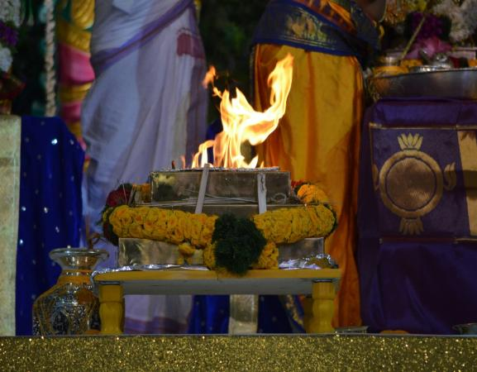Maghi is a significant cultural and religious festival primarily observed in Punjab and by the Sikh community around the world. Celebrated annually in January, it holds great historical importance, especially in relation to Sikh history. The festival commemorates the martyrdom of the "Forty Liberated Ones" (Chali Mukte), who died fighting for Guru Gobind Singh against the Mughal forces.

**Origins and Historical Background**

**Maghi in Vedic and Hindu Tradition**

Maghi is traditionally linked with the Hindu festival of Makar Sankranti, which marks the sun’s transition into the zodiac sign of Capricorn (Makara). It is considered an auspicious day in the Hindu calendar and symbolizes the end of winter and the beginning of longer, warmer days. The day is often celebrated by bathing in holy rivers and offering food to ancestors.

**Sikh Significance: The Forty Martyrs**

In Sikh history, Maghi holds a unique place due to the martyrdom of forty Sikh warriors who had previously deserted Guru Gobind Singh during the siege of Anandpur Sahib in 1705. Upon realizing their mistake, they returned and fought valiantly against the Mughal army at Muktsar, Punjab. All but one, Mahan Singh, were killed. Before dying, Mahan Singh had the Guru tear the document of desertion, and they were thus spiritually "liberated." The event is commemorated every year during the Maghi Mela in Sri Muktsar Sahib.

**Cultural Observance and Festivities**

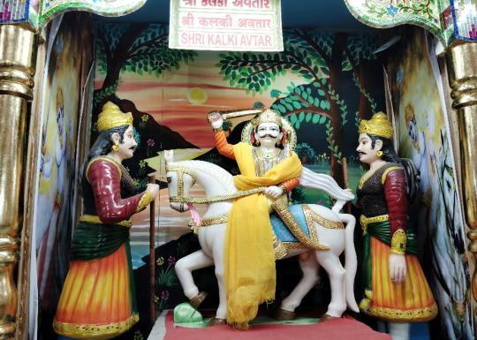**Maghi Mela at Muktsar Sahib** The most prominent celebration takes place in Sri Muktsar Sahib, Punjab, where thousands gather annually for the Maghi Mela. Pilgrims take a holy dip in the sarovar (sacred tank), attend religious processions, and listen to kirtan and katha (religious discourses). The mela is both a spiritual and social event, with markets, cultural shows, and community kitchens (langars).

**Regional Practices**

Outside of Punjab, Maghi is celebrated under various names across India—such as Pongal in Tamil Nadu, Uttarayan in Gujarat, and Lohri (the evening before Maghi) in North India. While cultural expressions vary, they all signify renewal, thanksgiving, and community bonding.

**Conclusion**

Maghi stands as a vibrant expression of both cultural continuity and historical memory. For Sikhs, it is a solemn occasion of reflection and tribute to those who sacrificed their lives for faith and righteousness. The festival also resonates with broader Indian traditions of seasonal change and spiritual rejuvenation. Whether observed through religious rites, historical remembrance, or cultural festivities, Maghi continues to be a meaningful occasion that connects communities across generations.

**References**

1. Singh, Khushwant. *A History of the Sikhs: Volume 1 (1469–1839)*. Oxford University Press, 2004.
2. Grewal, J.S. *The Sikhs of the Punjab*. Cambridge University Press, 1990.
3. Singh, Harbans. *The Encyclopedia of Sikhism*. Punjabi University, Patiala.